WHAT IS MARKETING? HOW MARKETING WORKS? WHAT IS DIGITAL MARKETING?

- Pick any two apps you use daily (like Instagram, Zomato, or Flipkart) and describe one marketing strategy each app uses to attract or retain users.

- Instagram : Influencer Marketing
Reason : Instagram uses popular creators and influencers to make Reels and posts. This attracts more people and keeps users active.

- Zomato : Offers And Discount
Reason : Zomato gives discounts, deals, and sends notifications. This encourages people to order food again.

- Create a simple poster (digital or on paper, then click a photo) for a new food delivery service, highlighting one digital marketing channel you would use to promote it.<br><br><em><strong>Hint:</strong> Think about using Instagram ads, WhatsApp broadcasts, or influencer partnerships.</em>
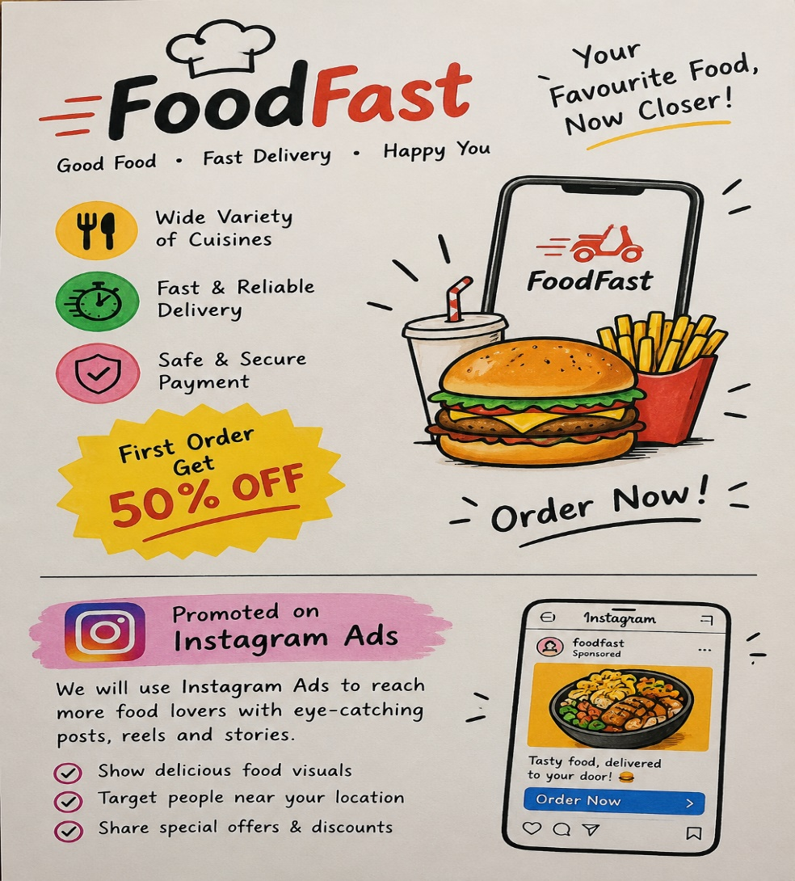

- For my new food delivery service FoodFast, I would use Instagram Ads as my digital marketing channel.

- Post attractive food photos and videos on Instagram.
- Use Reels and Stories to reach more people.
- Show special offers like “50% OFF on First Order.”
- Target people in nearby locations.
- Add an “Order Now” button to encourage customers to order.

- List 5 differences between traditional marketing (like newspaper ads, flyers) and digital marketing (like social media ads, email campaigns) in a table format.

POINT | TRADITIONAL MARKETING | DIGITAL MARKETING
PLATFORM | Uses Newspaper, TV, Radio, Posters | Uses Instagram, Facebook, Google, mail
COST | Usually more expensive, especially TV and newspaper ads. | Can be cheaper and flexible according to budget.
REACH | Mostly reaches people in a specific area or region. | Can reach people anywhere in the world.
TARGETING | Difficult to target a specific type of customer. | Easy to target customers by age, location, interests, etc.
RESULTS | Results are harder to measure accurately. | Results can be easily measured through clicks, views, likes, sales, etc.

- Imagine you are launching a new playlist feature for a music app like Spotify. Write a short plan (5-6 lines) on how you would use digital marketing to get college students to try it.<br><br><em><strong>Hint:</strong> Mention specific digital channels or tactics, such as Instagram Reels, YouTube ads, or meme marketing.</em>
- We will use Instagram Reels to show the new playlist feature.
- We will use YouTube ads to reach college students.
- We will create fun memes about music and college life.
- We will ask college influencers to promote the feature.
- We will use Instagram Stories and polls to engage students.
- We will send app notifications to tell users about the new feature.

